Advice Trainee
Job pack

Thanks for your interest in working at Citizens Advice Mid-North Yorkshire. This job pack should give you everything you need to know to apply for this role and what it means to work at Citizens Advice.

In this pack you’ll find:
- Our values
- 3 things you should know about us
- Overview of Citizens Advice and Citizens Advice Mid-North Yorkshire
- The role profile and personal specification
- Terms and conditions
- What we give our staff
Want to chat about this role?
If you want to chat about the role further, you can contact Charlotte Wild by emailing charlotte@northyorkslca.org.uk or calling 01757 701320 Ext: 1030.

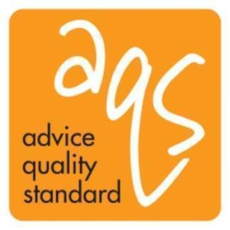
Our values
We’re inventive. We’re not afraid of trying new things and learn by getting things wrong. We question every idea to make it better and we change when things aren’t working.
We’re generous. We work together, sharing knowledge and experience to solve problems. We tell it like it is and respect everyone.
We’re responsible. We do what we say we’ll do and keep our promises. We remember that we work for a charity and use our resources effectively.
3 things you should know about us
1. We’re local and we’re national. We have 6 national offices and offer direct support to people in around 300 independent local Citizens Advice services across England and Wales.

2. We’re here for everyone. Our advice helps people solve problems and our advocacy helps fix problems in society. Whatever the problem, we won’t turn people away.

3. We’re listened to - and we make a difference. Our trusted brand and the quality of our research mean we make a real impact on behalf of the people who rely on us.

How Citizens Advice Mid-North Yorkshire works

We deliver our service from offices based in Northallerton, Malton, Richmond, Selby, Skipton, Harrogate, Scarborough and Whitby. We give advice face to face, over the phone, and via web chat and email. We help around 18,000 people a year on all types of issues. We are an independent charity raising all our own money, and each of our offices has its own identity within the local community.
Overview of Citizens Advice
The Citizens Advice service is made up of Citizens Advice - the national charity - and a network of around 300 local Citizens Advice members.  This role sits within our network of independent charities, delivering services from  - over 600 local Citizens Advice outlets  - over 1,800 community centres, GPs’ surgeries and prisons  They do this with:  - 6,500 local staff  - over 23,000 trained volunteers  Our reach means 99% of people in England and Wales can access a local Citizens Advice within a 30 minute drive of where they live. | 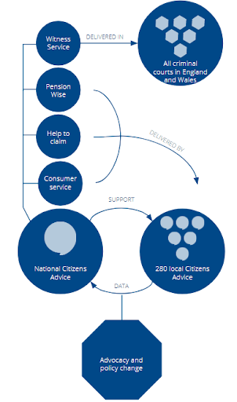

Advice Trainee role profile

The role is to train as an adviser. You will learn about all aspects of our work including giving advice through various channels, mainly the telephone but also email, webchat and face to face. You will learn about our research & campaigns work. The trainee role will lead on to developing your knowledge and skills in different enquiry areas and/ or to develop support and supervision skills.
Information gathering

- Answering telephone calls/emails/web chats from members of the public in a sensitive and sympathetic manner
- Ensuring GDPR and that consent is gathered from the client.

Advice giving

- Interview clients using sensitive listening and questioning skills in order to allow clients to explain their problem(s) and empower them to set their own priorities
- Use Citizens Advice resources to find, interpret and communicate relevant information to clients
- Complete benefits checks when appropriate
- Act for the client where necessary using appropriate communication skills and channels
- Refer internally or to other specialist agencies as appropriate
- Ensure all work meets quality standards and the requirements of the funder and Citizens Advice
- Ensure work reflects and supports Citizens Advice's equality and diversity strategy
- Maintain detailed case records for the purpose of continuity of casework, information retrieval, statistical monitoring and report preparation
- Complete the required training to comply with quality assurance processes.

Professional development

- Keep up to date with legislation, policies and procedures and undertake appropriate training
- Attend relevant meetings.

Administration

- Use of IT software for statistical recording of information relating to research and campaigns and funding requirements, record keeping and document production
- Ensure GDPR compliant training is completed on an annual basis
- Ensure all work conforms to the organisation’s systems and procedures.

Other duties and responsibilities

- Carry out any other tasks that may be within the scope of the post to ensure the effective delivery and development of the service
- Demonstrate commitment to the aims and policies of Citizens Advice
- Abide by health and safety guidelines and share responsibility for your own safety and that of colleagues.

Person specification

Essential

- Ability to use sensitive listening and questioning skills to get to the root of the issues and empower clients, whilst maintaining structure and control of the calls with them

- Ability to research and interpret complex information, and communicate this clearly, verbally and in writing

- Ability to give and receive feedback objectively and sensitively and a willingness to challenge constructively

- Good IT knowledge and the ability to use IT systems and packages, and resources in the provision of advice, record keeping and document production

- Ability to work in a confidential environment with an understanding of information assurance and safety in those settings

- Willingness and ability to commit to a rota within the core hours of the service

- Ability to commit to and work with the aims, principles and policies of the Citizens Advice service

- A good up to date understanding of equality and diversity and its application to the provision of advice

- Ability to monitor and maintain standards for advice provision and quality assurance.

Desirable

- Experience within Citizens Advice service and already working towards developing knowledge of multiple enquiry areas.

Terms and conditions

We will discuss terms and conditions with you if you are offered the Advice Trainee role.

What we give our staff
You will have access to our pensions and support service.
We are a disability confident employer and welcome candidates who will be using access to work.

